Summary Report – Assignment 2

By David Wilkinson

For this assignment, I tested several combinations of layer node sizes, number of layers, and accuracy improvement techniques. After tuning the hyperparameters, the highest percentage accuracy on unseen data came to 88.77%. The textbook indicated that 88% could be easily achieved even after a naïve approach. However, I was unable to improve accuracy to 95%, which the textbook indicates can be achieved with state-of-the-art models.

After several combinations, I note that the first layer should be larger than the second. There should only be two layers, and dropout regularization was used at a rate of 0.5. At last, it came to 2 dense layers with 16 nodes, and 8 nodes, respectively, using the relu function.

Testing the model on unseen data (which had been tuned on validation data), was most accurate when using 7 epochs of training.

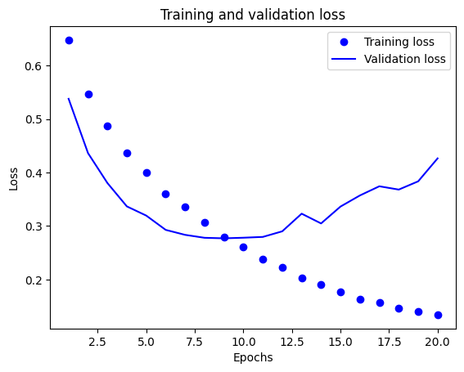

Chollet, François . Deep Learning with Python, Second Edition (p. 105). Manning. Kindle Edition.